SARDC BOARD

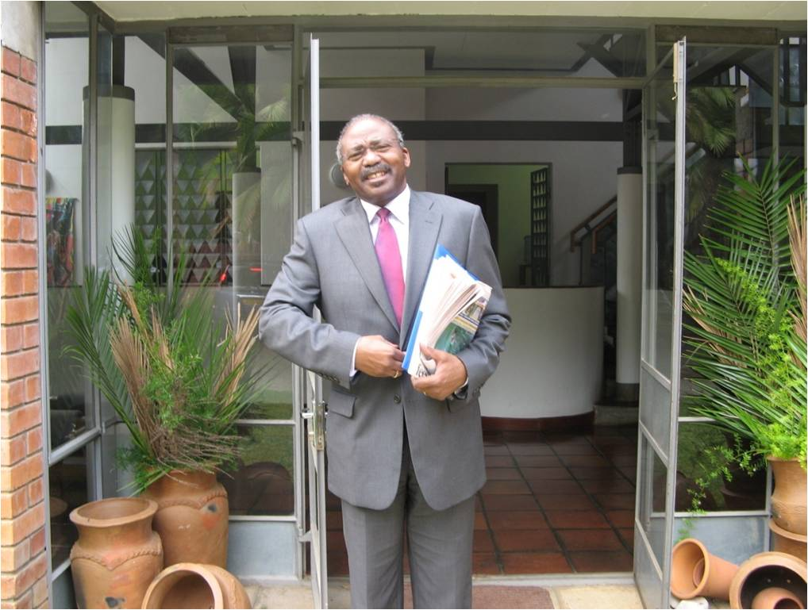

Southern African Research and Documentation Centre

CHAIRPERSON
Hon Professor Peter H Katjavivi, MP

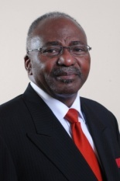
Speaker of the National Assembly
Parliament of Namibia
Parliament Building, 14A Love Street
Windhoek, NAMIBIA
www.parliament.na

Hon Professor Peter H. Katjavivi, MP was elected Speaker of the National Assembly of Namibia in March 2015, after serving for five years as Government Chief Whip in Parliament. He is also a member of the SADC Parliamentary Forum and the Pan-African Parliament. Hon Prof Katjavivi is a widely respected academic and historian who was Founding Vice-Chancellor of the University of Namibia established after Independence, serving from 1992-2003 and transforming a previously segregated institution into a university with national character and relevance. He is a leading member of the South West Africa People’s Organisation (SWAPO). He played a prominent role in the liberation struggle of Namibia, building international support through diplomatic activity, as SWAPO representative in UK and Western Europe. He has devoted his life to the cause of social justice. He returned to Namibia in 1989 in preparation for independence on 21 March 1990. He was a member of the Constituent Assembly that drafted the constitution and a signatory to the Independence Constitution. Appointed in 2003, he served Ambassador to the Kingdom of Belgium and the European Union, and then to Germany. In 2008 he was appointed Director General of the National Planning Commission in the Office of the President. He has served on the boards of various international bodies and associations, particularly in education and development. Hon Prof Katjavivi has a D. Phil from Oxford University, UK and a Masters from Warwick. His previous studies were in Nigeria and Tanzania. He was later a visiting fellow at Yale University, USA. He has written and edited several books, historical documents and papers, mainly about the liberation struggle. He speaks six languages.

VICE CHAIRPERSON
Arlindo Lopes
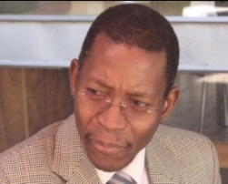

Consulting Manager
MultiChoice Southern Africa
Johannnesburg, South Africa
Email: pokete@gmail.com

MOZAMBIQUE

The Vice Chairperson of the SARDC Board is Arlindo Lopes from Mozambique. He is a former Secretary General of the Southern African Broadcasting Association (SABA), before moving to MultiChoice Southern Africa as a consulting manager. He has recently retired as General Manager (Regulatory and Corporate, Angola and Mozambique) for MultiChoice Africa Ltd. He is a former Chairperson of Televisão Moçambique (TVM) and of the Union of National Radio and Television Organisations of Africa (URTNA), which was revitalized under his leadership. He is a respected journalist and media consultant with more than 35 years experience on various newspapers including a local daily Diário, the national newspaper Notíçias (as reporter, news editor and director), Tempo news magazine as senior writer, and the Sunday newspaper Domingo as senior writer. From 1987 he was in government service, becoming National Director (Permanent Secretary) in the Ministry of Information and after 1995, Director of Information in the Office of the Prime Minister. He has an MA in Media Ecology from New York University.

BOARD MEMBER
Nthobakae (Nthobi) Lifelile Angel
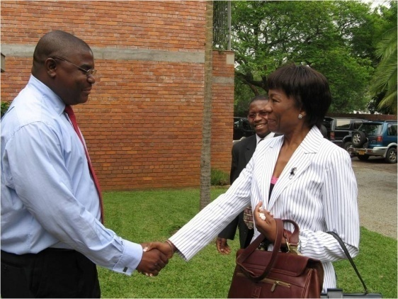
TsaRona Investments
Johannesburg, SOUTH AFRICA
Email: nlangel@iafrica.com

Nthobi Angel is the Chairman of TsaRona Investments, an empowerment company in South Africa, and Co-Chairman of Kagiso Tiso Holdings Pty Ltd. She is a director of Batho-Bonke Capital, Trustee of Kagiso Trust, and a Board Member of Deloitte & Touche. She has extensive experience in the corporate world and in communications, including as Chief Operating Officer for Strategic Planning and Communications in the Presidency, 2001-2003. She worked at Engen Petroleum for six years, as General Manager for Corporate Affairs and then Executive Director Strategic Affairs. She was CEO of Mvelaphanda Resources, and Managing Director, External Relations Division of Eskom Holdings. She did all of her tertiary studies in exile in Africa, including Ghana, Zimbabwe and the United Republic of Tanzania, earning a BA Honours degree, BSc Honours and MSc in Sociology, as well as a postgraduate diploma in Mass Communication. She speaks seven languages, including English, French, Swahili and four South African languages.

BOARD MEMBER
Professor Reginald H Austin
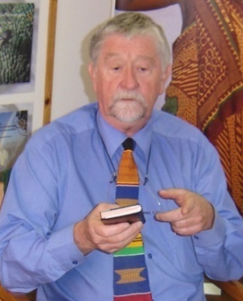

Harare, ZIMBABWE
Email: regaustin182@gmail.com

Professor Reg Austin is a Zimbabwean law professor who was active in the liberation struggle and was a member of the legal team for the independence negotiations at Lancaster House in London in 1979. He was Dean of Law at the University of Zimbabwe after Independence. He was later Director and Chief Electoral Officer of the UN Observer Mission to South Africa (UNOMSA) for the 1994 transitional elections, and UN Director of Elections in Cambodia in 1993. He organised the successful national elections in Afghanistan in 2003, and the Solomon Islands in 2006. He was appointed by the UN Secretary-General as one of three high-level electoral experts to verify the conduct of each phase of the electoral process in East Timor for presidential and parliamentary elections in 2007. Prof Austin has facilitated a number of key initiatives for SARDC including observation of Zambia’s first multi-party elections and the first multi-party conference on elections in Angola (both 1991), and contributed to SARDC workshops for pre-independence Namibia (1989) and post-conflict Mozambique (1992). He was Chief Electoral Officer of UNAMA (2002) in Afghanistan; Director of the Legal and Constitutional Division of the Commonwealth Secretariat (1993-98) and a Director at International IDEA in Stockholm (1998-2002). He was the first chairman of the Zimbabwe Human Rights Commission.

BOARD MEMBER
Ruhiza Jean Boroto

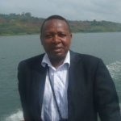
Senior Water Resources Officer
FAO Regional Office for Africa
Accra, Ghana
Email: ruhizaboroto@gmail.com

DEMOCRATIC REPUBLIC OF CONGO

Ruhiza Jean Boroto is a civil engineer and water specialist from the Democratic Republic of Congo (DRC), who has been a consultant and advisor to the South African government and other SADC governments on water resources management. Since 2011, he is the Senior Officer (Water Resources) for the UN Food and Agriculture Organization (FAO) at the Regional Office for Africa, located in Accra, Ghana. Jean Boroto did his post-graduate studies at Stellenbosch University (M Eng Civil, Water Eng), and is a registered Professional Engineer in South Africa where he worked for the Department of Water Affairs and Forestry, as Director of Project Planning. He works on issues of land, water and climate change, and has recently become the FAO focal point for energy in Africa. He is the Delivery Manager for FAO’s regional initiative on the Sustainable Intensification of Agriculture Production and Value Chains Development. In addition to his wide knowledge of the challenges and opportunities facing the water sector in southern Africa, he is a motivational writer on issues related to personal development.

BOARD MEMBER
Godfrey Madaraka Nyerere

JKN Hotels (Butiama)
Box 620, Musoma,
UNITED REPUBLIC OF TANZANIA
Email madaraka.nyerere@gmail.com

Godfrey Madaraka Nyerere is a writer and cultural tourism specialist who lives at Butiama, in northern Tanzania. He is Director of JKN Hotels Ltd, which offers visitors the opportunity to stay at Mwitongo in the village of Butiama that is the birthplace of Tanzania’s founding President, Mwalimu Julius Kambarage Nyerere, who was buried there after his death on 14 October 1999. The Julius Nyerere Library is located at Mwitongo and the Julius K. Nyerere Museum is nearby. Cultural and historical tours are available, and performances of traditional dances from the Mara region, as well as nature hikes. The accommodation comprises 10 rooms in a main building and two chalets. Madaraka Nyerere lists mountaineering as one of his interests, whether it’s a one-hour climb up the nearby Mt Mtuzi or several days climbing the rather higher Mt Kilimanjaro, a feat he has accomplished eight times and continues to climb annually for the Mwalimu Nyerere Charity Climb. He is the sixth child and youngest son of Julius and Maria Nyerere. A banker by training and a former columnist for the national weekly, the Sunday News, in Tanzania, he now maintains his column through a popular blog, From Butiama and beyond…

BOARD MEMBER
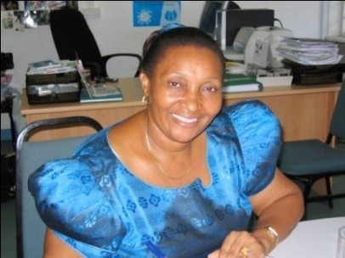
Mary Rusimbi

Women Fund Tanzania
659 Mikoroshini Street, Namanga, Msasani
P.O. Box 79235, Dar es Salaam,
UNITED REPUBLIC OF TANZANIA
www.wft.or.tz
Email: mary.rusimbi@gmail.com
Mary Rusimbi is co-founder and Executive Director of the Women Fund Tanzania whose goal is to contribute towards women’s rights and empowerment. She is also a founding member of the Tanzania Gender Networking Programme (TGNP), where she was Executive Director for 10 years until 2007. Three years later, she was elected Chairperson of TGNP, a widely respected umbrella group and network that supports community development and gender advocacy. She is an organizational development specialist and trainer with more than 25 years of experience in gender policy analysis and formulation, trainer in gender responsive budgeting, and a long-time activist who has worked in development agencies and served on the board of a number of non-governmental agencies. She has accumulated considerable regional gender knowledge and experience which she is often called upon to share as a consultant in the SADC region. As a founder and board member of several organizations, she has played key leadership roles in the women's movement for many years, in promoting gender equality, equity and social transformation nationally, regionally and internationally. She has written widely on the prospects for gender equality, including a gender-reference checklist for elections. She has published numerous articles and book chapters on gender and development issues. She holds a Masters degree in Education from University of Auckland, and a Bachelors degree in Education from the University of Dar es Salaam.

BOARD MEMBER
Dr Anderson B Shankanga

Education and International Development Adviser
Harare, Zimbabwe
Email: shankangab@yahoo.co.uk

ZAMBIA

Dr AB Shankanga is an educational specialist and consultant, and former UNESCO regional director, with more than 30 years experience in developing and strengthening education at national, regional and continental levels. He was Founding Director of the Institute for Peace, Leadership and Governance at Africa University in Mutare, Zimbabwe, and later Senior Research Adviser at Africa University. Dr Shankanga is an education and governance specialist from Zambia, and former Director of the UNESCO Sub-regional Office for Southern Africa, where he worked with SADC in establishing a consultative conference of Ministers of Education and on the SADC Initiative in Education Policy Development, Planning and Management. He served in the UN system for more than 20 years, after leaving the Ministry of Education in Zambia. He has a doctorate in Curriculum Development from the University of Southern California.

BOARD MEMBER
Dr Gloria Somolekae
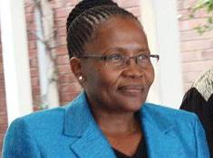
Gaborone
BOTSWANA

Dr Somolekae is a specialist in organizational development and public administration, as well as governance and elections. She taught public administration at the University of Botswana, and later headed the university’s Democracy Research Project. She was appointed by the President as Chairperson of the Vision 2016 Council, in which role she dynamized the implementation countrywide. She later administered a programme of local development projects in Botswana for an international foundation before being appointed as regional director of programmes. She was also a member of the President’s Commission on Traditional Leadership in Botswana. She served as a Member of Parliament and deputy Minister of Finance, later Assistant Minister for Presidential Affairs and Public Administration, responsible for addressing poverty, HIV and AIDS, and other vulnerabilities. She serves on the Board of Letshego Holdings Ltd as an independent non-executive director. Dr Somolekae has built an illustrious career spanning over 30 years, in academia, philanthropy, and the public sector. She has served on the Board of the African Capacity Building Foundation and the African Development Bank, among others. She holds a BA from University of Botswana, Masters in Public Policy and Administration from the Institute of Social Studies in The Hague, and a PhD in Public Administration from Maxwell School of Syracuse University in the USA. She has written books, research projects, papers and reviews.

FOUNDING DIRECTOR AND SPECIAL PROJECTS

Phyllis Johnson
SARDC
Julius K. Nyerere House
15 Downie Avenue, Belgravia,
Harare, ZIMBABWE
Tel: 263 4 791141
Email: pjsardc@gmail.com

The Founding Director of SARDC responsible for Special Projects is a writer, editor, broadcaster and publisher, a long-time resident of southern Africa and student of southern African affairs. She has played a role in institution building at SARDC and elsewhere, including the Zimbabwe Publishing House, Zimbabwe International Book Fair, and the African Publishing Group, as well as SARDC’s Institute for China Africa Studies in Southern Africa. She has written and edited numerous books and articles, mainly on the historical, socio-political and security dimensions of regional development, and also on regional policy issues on environment and water issues, as well as gender. She has written several books on the liberation struggle in southern Africa, including The Struggle for Zimbabwe, Frontline Southern Africa: Destructive Engagement, Apartheid Terrorism: The Commonwealth Report, The Chitepo Assassination, and a biography of the former Commonwealth Secretary-General, Chief Emeka Anyaoku, entitled Eye of Fire. She was born in Canada but has spent more than half of her life in Africa, and made her home in Zimbabwe, with her husband, the late journalist and historian David Martin.

EXECUTIVE DIRECTOR
Munetsi Madakufamba
SARDC
Julius K. Nyerere House
15 Downie Avenue, Belgravia, Harare, ZIMBABWE
Tel 263 4 791141
Email mmadakufamba@sardc.net

The Executive Director of SARDC is an economist and specialist in regional development and integration, and has a deep knowledge of SADC issues, opportunities and challenges over the past two decades. He has played a significant role in policy analysis for the regional industrialization agenda, and served on the Task Force that developed the Revised Regional Indicative Strategic Development Plan (RISDP 2015-2020). He is Editor of the official SADC magazine Southern Africa Today (SADC Today), a prestigious publication produced by SARDC since 1997. He has presented various papers at conferences and think tanks in China and elsewhere, most recently on the application of Special Economic Zones in southern Africa. He has a BSc in Economics and a Masters in International Relations from the University of Zimbabwe. He writes widely on regional economic development and integration, including the current challenges of infrastructure and energy supply, and the opportunities of renewable energy. He is an adviser to the SADC Energy Thematic Group, among others.

SARDC FOUNDING DIRECTOR
David Martin (Late)

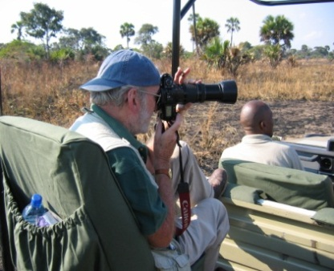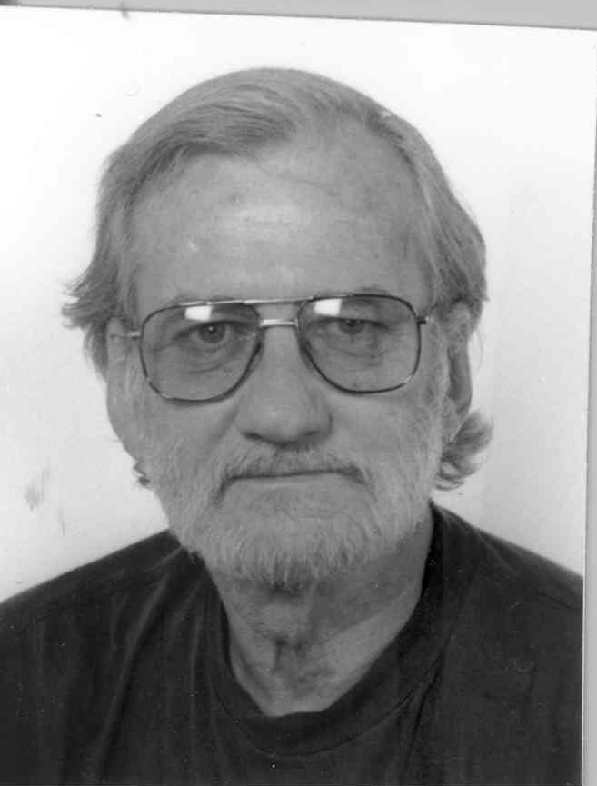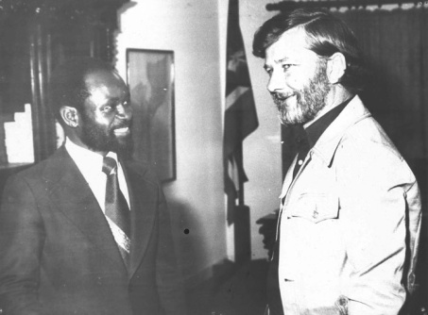
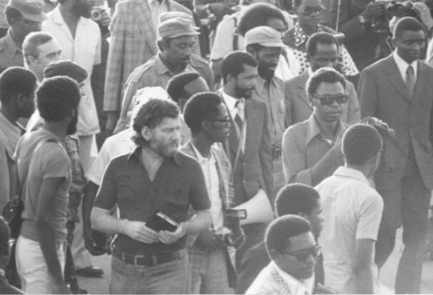
Chairman and CEO, African Publishing Group
Box BW-350, Harare, Zimbabwe

Chairman of African Publishing Group (APG) and a founding director and former Chairman of Zimbabwe Publishing House (ZPH) as well as the Zimbabwe International Book Fair, David Martin was an accomplished writer, photographer and investigative journalist. He worked in the national media in the United Republic of Tanzania (Tanganyika Standard) and the UK (Africa correspondent of The Observer) as well as writing for other media in Africa and Europe. He wrote the first book exposing the regime of Idi Amin in Uganda, titled General Amin. He marched with the Mozambique Liberation Front (Frelimo) in the liberated zones in 1973 prior to Independence in 1975. David Martin wrote several books about the liberation of southern Africa, including The Struggle for Zimbabwe and others with Phyllis Johnson, and promoted the marketing of African history through area-specific tourism guides. He was the author and photographer of Into Africa Travel Guides, a series of more than 20 area-specific guidebooks for visitors, primarily on Tanzania, published in collaboration with Tanzania National Parks (Tanapa). Others are on places in Mozambique, Namibia and Zimbabwe. He was a visionary writer who applied the knowledge he acquired from his close relationship with Presidents Julius Nyerere in Tanzania and Samora Machel of Mozambique as well as the legendary commander of the Zimbabwe liberation forces, General Josiah Tongogara, Robert Mugabe, Sam Nujoma, OR Tambo, Eduardo Mondlane, Kenneth Kaunda, Agostinho Neto and others. He was widely respected for his honesty, integrity and trust, reflected through his writing and his relations with people. (b 14 April 1936 d 18 August 2007)

SARDC FOUNDING PATRON
Mwalimu Julius Kambarage Nyerere (Late)

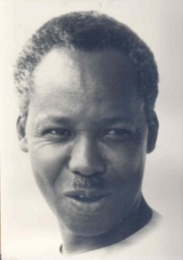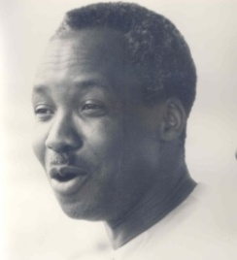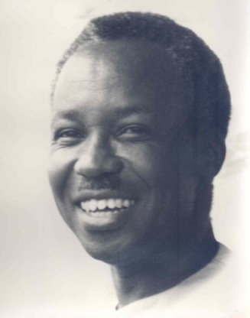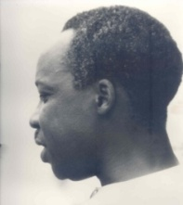 Photos Colin Fox, 1967

Mwalimu Julius Kambarage Nyerere became an icon in Africa for his vision and steadfast support for the liberation of the continent from colonial control, and for unifying his country made up of more than 120 ethnic groups and two administrations (Mainland formerly Tanganyika, and Zanzibar) into the United Republic of Tanzania. Although Independence day is marked in 1961 and Union day in 1964, he was very clear that his country would not be free until the rest of Africa was free, including apartheid South Africa, a feat achieved in 1994. For 30 years from 1964 to 1994, his country hosted the Organization of African Unity (OAU) Liberation Committee, mobilizing material support for the liberation movements. He did this not only as President, but he mobilized the entire population behind him, with individuals giving one or two shillings in “people-to-people” support. Tanzanians, even in rural areas, are very much aware of their neighbours and his legacy to this day. His pre-independence statement to the Legislative Council in 1959 is regarded as a classic and much-quoted,
“We the people of Tanganyika would like to light a candle and put it on top of Mount Kilimanjaro which would shine beyond our borders, giving hope where there was despair, love where there was hate, and dignity where before there was only humiliation.”
Nyerere chaired the informal regional grouping of independent Front Line States from its inception in 1974 until he retired as President of Tanzania in 1985. He understood that political liberation was only the beginning and that it was necessary for people of the region to begin to think about the future in a unified regional context. He wanted to create an institution to document and research relevant issues from a regional perspective. This was discussed by David Martin and the Tanzanian Foreign Minister, Benjamin Mkapa, in Maputo in 1977 at the UN Conference in Support of the Peoples of Namibia and Rhodesia, and with President Kaunda in Zambia. However, it took another eight years for the Southern African Research and Documentation Centre (SARDC) to emerge in 1985, with its first publication in 1986, and to have premises in January 1987, in Harare and Maputo (following the instruction of the late President Samora Machel in 1986). During that period, Nyerere chaired the South Commission and became the first Chairman of the South Centre, an institution of and for developing countries, and in 1989, he agreed to be become the Founding Patron of SARDC.
Mwalimu Nyerere was Prime Minister of Tanganyika from Independence in December 1961 to December 1962 when he became President. He brought the islands of Zanzibar into a Union in 1964, to form the United Republic of Tanzania. He was born in northern Tanzania, in the village of Butiama, near Musoma, in 1922 and he was educated at Tabora Government Secondary School, Makerere University in Uganda where he earned his diploma in education, and Edinburgh University in Scotland where he obtained his Master of Arts degree in Economics and History in 1952. He was the first Tanzanian to attend a UK university, and the second to gain a university degree outside of Africa. (b 13 April 1922 d 14 October 1999)

Asante Sana, Thank You Mwalimu is the title of a book published by SARDC with African Publishing Group and others in 2015. The book contains historical photos of Nyerere and key excerpts from his speeches. The Introduction is written by David Martin about Mwalimu, and the Foreword is by President Robert Mugabe of Zimbabwe, then chairman of SADC and the African Union. The book is available from SARDC, African Publishing Group and bookshops, and from the co-publishers – House of Books, Mkuki na Nyota, and National Gallery of Zimbabwe.

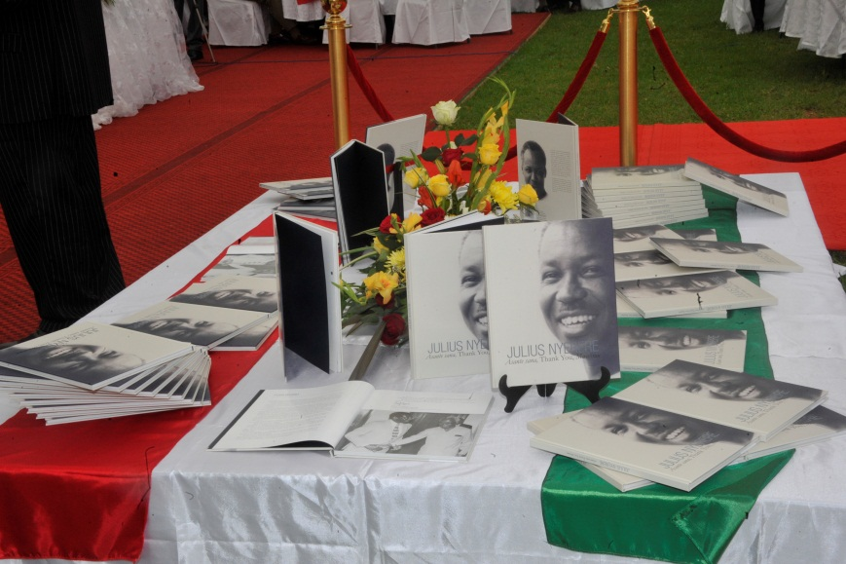

The classic story about his transformation of the country in the first 10 years after Independence, titled Nyerere of Tanzania by William E. Smith, and a book written by Mwalimu Nyerere in 1995 about the political importance of the national Union, Our Leadership and the Destiny of Tanzania (English and Swahili), are available from
African Publishing Group, Harare
Email apg@africanpublishinggroup.com

Three volumes of speeches are available from Mwalimu Nyerere Foundation in Dar es Salaam, Tanzania
Website www.nyererefoundation.or.tz
NYERERE Freedom and Unity/ Uhuru na Umoja, Selection from Writings & Speeches 1952-1965, OUP 1967
NYERERE Freedom and Socialism/ Uhuru na Ujamaa, Selection from Writings & Speeches 1965-1967, OUP 1968
NYERERE Freedom and Development/ Uhuru na Maendeleo, Selection from Writings & Speeches 1968-1973, OUP 1973

